Middle School Art Grading Rubric
How is Art Graded?
While it is difficult to grade art, the effort and quality put into a work can be assessed fairly by using the 5 C’s:
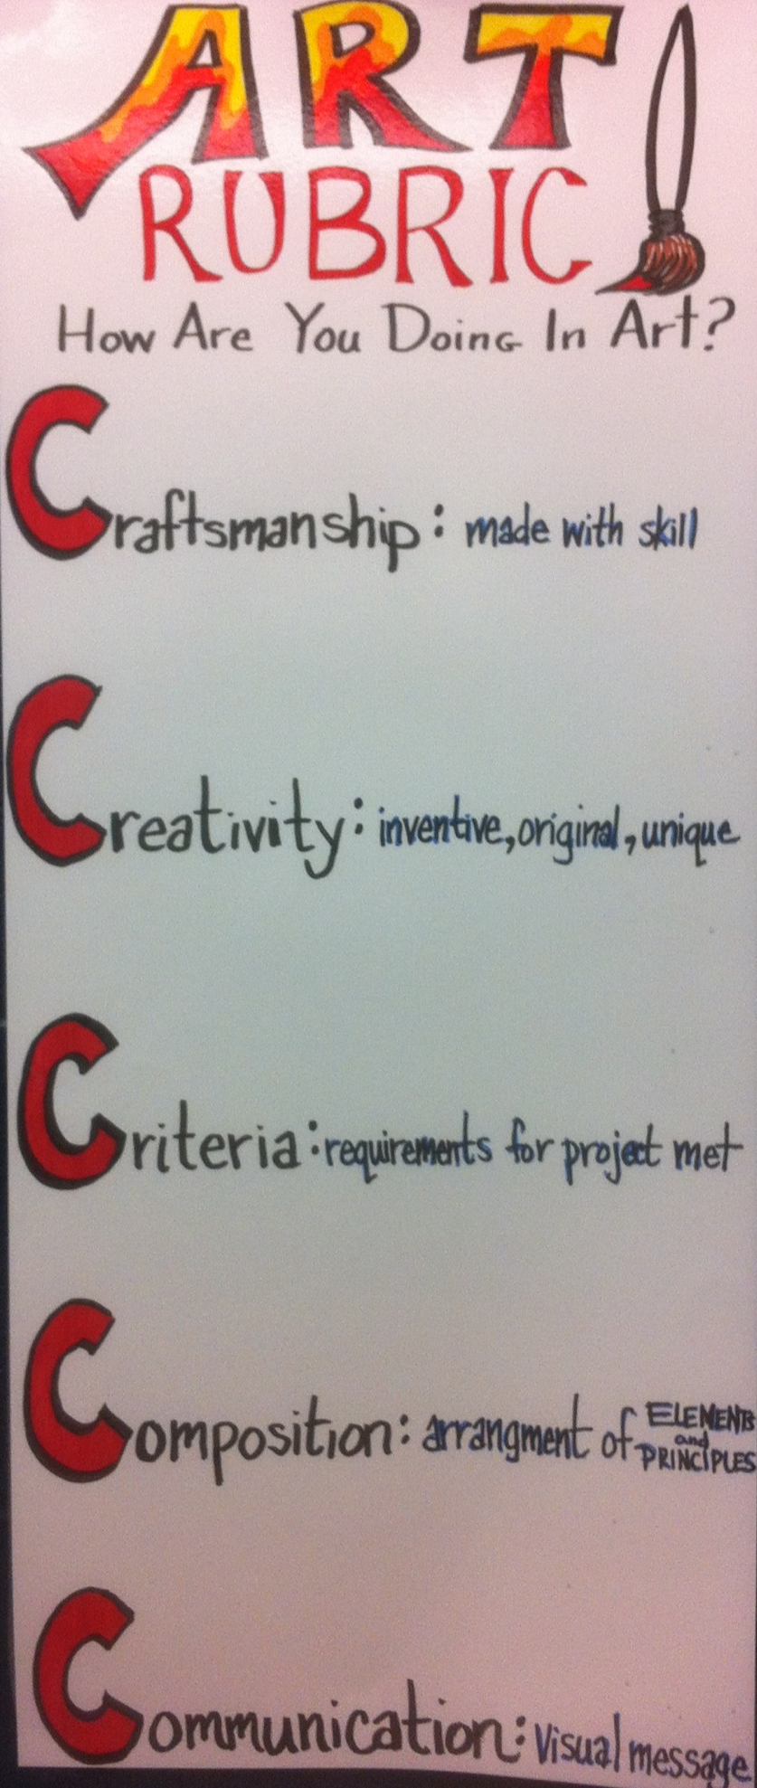
- Craftsmanship:
  - Use of tool and mediums; technical skills
- Creativity
  - Catch the viewer’s eye with original ideas/imagery
- Criteria
  - Followed Directions and meeting project objectives/goals
- Composition
  - Center of Interest created and visual use of image space
- Communication/Challenge
  - Visual communication of idea and artist statements
  - Preparation/Effort
Grades are giving on a 20-point scale in each of the above categories for major projects.
Grades: Points Art Rubrics
A 20 *Artwork was patiently done;
*Technical skills are excellent
*Student generated many ideas; made connections to previous knowledge; mastery of problem-solving skills.
*Demonstrates clear understanding of all the concept(s) taught.
*Composition is carefully planned. Fills Visual Space
*Clear and complete communication of idea; artist statement; effort beyond that required and student took pride in going well beyond basics.

B 17 *With a little more effort the work could have been outstanding; technical skills are good.
*The student tried a few ideas
*Concepts taught are evident in work but could be developed more clearly
Composition is generally strong; showed awareness of filling space adequately.
*Student worked hard and completed the project but with more effort it may have been excellent in communicating student’s expressive idea

C 15 *Needs work on tools and materials; technical skills need to be more developed
*The student tried one idea; lacks originality
*Concepts taught are minimally evident in work; student is minimally following guidelines of project.
*Composition is minimally developed; it is obvious the student did not clearly plan it out.
*Visual intention unclear; More effort needed

D 13 *Little knowledge of tools or materials; technical skills weak; lack of pride in finished work
*The student completed the assignment; imagery is copied from another source; very little evidence of trying anything unusual.
*Weak understanding of the concept(s) taught; student did not follow the guidelines of the project
*Composition is weak and undeveloped; no evidence of planning
*Lacking clear communication of idea; Student failed to utilize class time effectively and or missed many classes and failed to make up the time.

F 10- *Misuse of tools and materials
*Poor solutions to problems/artwork copied; no evidence of original thought
*No evidence of concept(s) presented in class.
*No aspect of composition is represented; pr the artwork was not complete
*Project incomplete. Poor artistic decision-making/student put forth no effort. Most classes were missed and student failed to make up the time.
*No Name

